Pre-Teen/Little Miss Wardrobe List:

Evening Wear: Long, floor length, age-appropriate dress *NO dresses with long trains
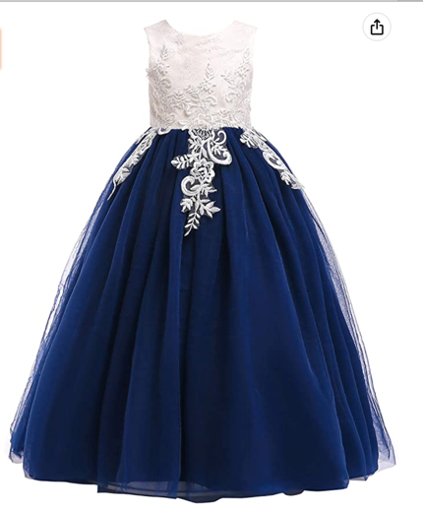
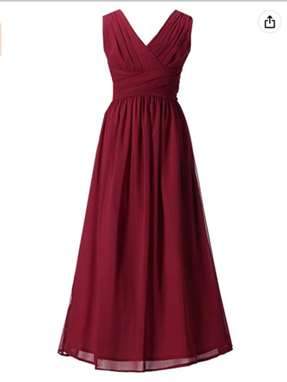
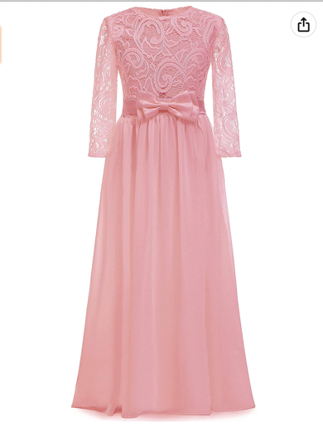
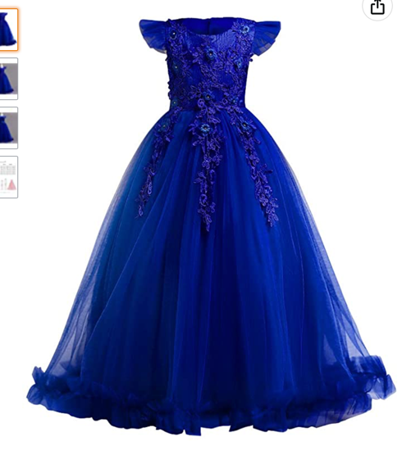
Examples: (Amazon has GREAT, AFFORDABLE dresses. All dresses below are from Amazon!)
Interview: age-appropriate solid colored dress or Jumpsuit
*Contestant will wear the SAME outfit for both the personal and onstage interview portions of competition
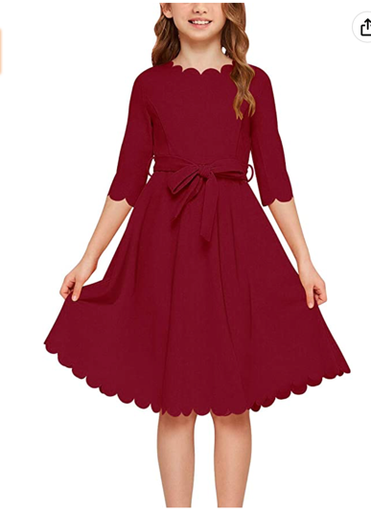
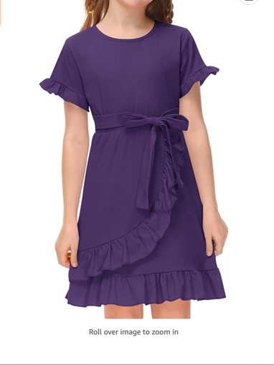
Examples:
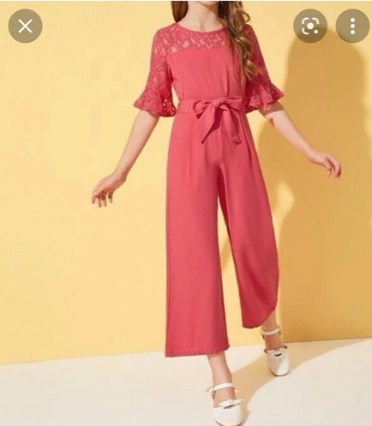

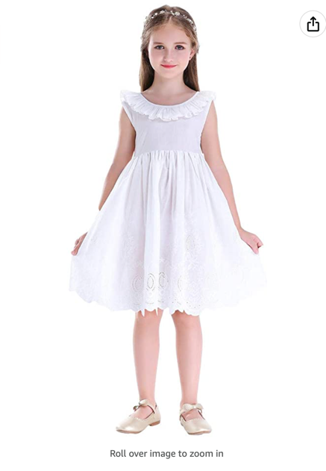
Opening/Closing Number: age-appropriate short, white dress. Flower girl dresses from weddings are great! *Keep in mind age-appropriate length when purchasing
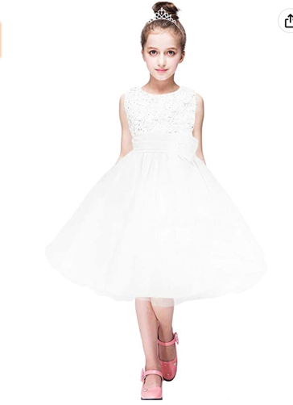
Examples: (Amazon has GREAT, AFFORDABLE options! All dresses below are on Amazon)
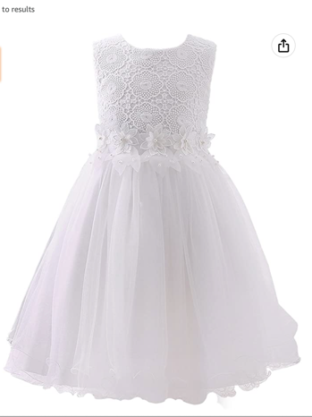
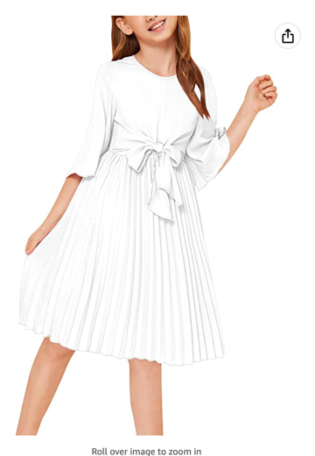

Active Wear: fitness style outfit- leggings, tanks, skorts, crops, capri leggings
Examples: (Amazon has GREAT, AFFORDABLE options! Below are ALL from Amazon!)

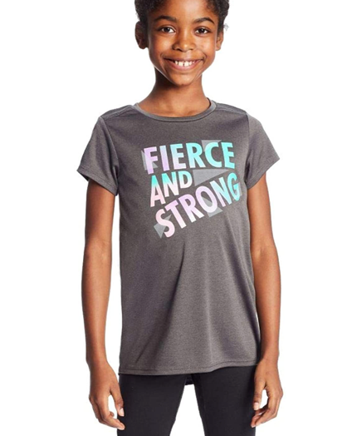
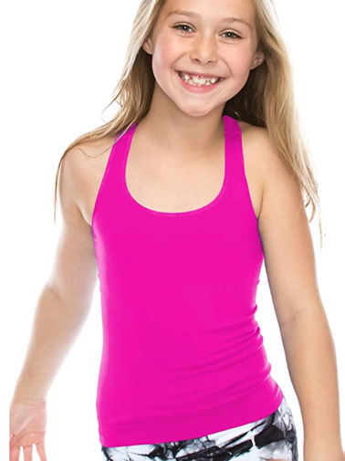
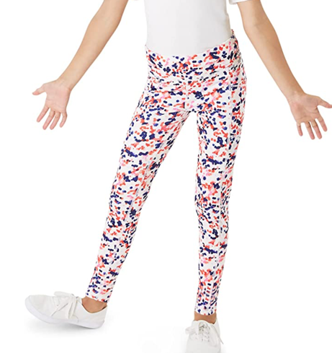

Shoes:
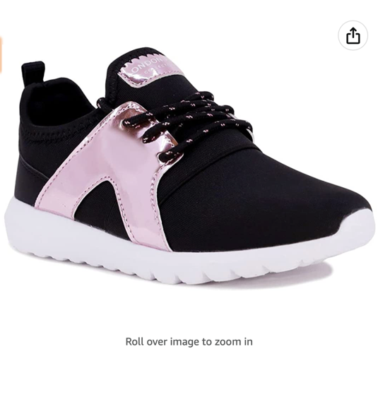
Active Wear: any color Tennis Shoe. P.E. shoes work GREAT!
Examples: (Amazon has GREAT, AFFORDABLE options! Below are ALL from Amazon!)

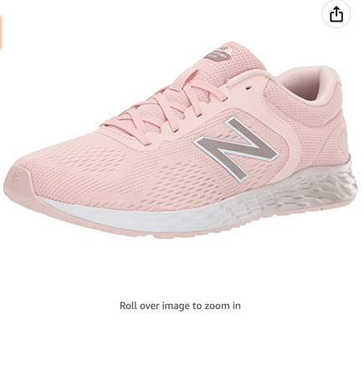
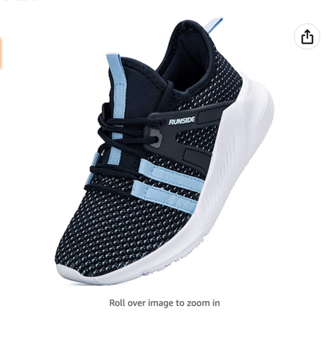

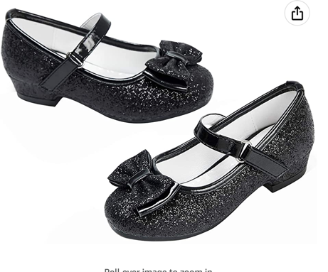
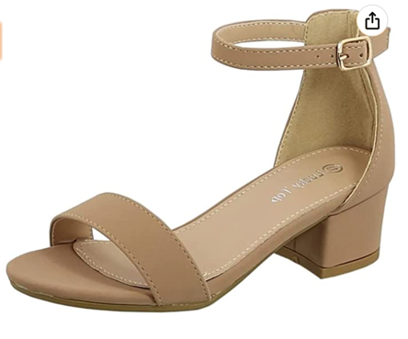
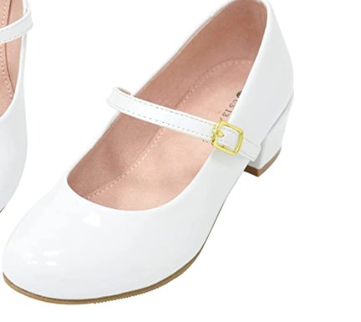
Every other area of competition: SHORT dress heel. *NO GREATER than 1.5 inches
Examples: (Amazon has GREAT, AFFORDABLE options! Below are ALL from Amazon!)

